

**FACULTY OF INFORMATION AND COMMUNICATION TECHNOLOGY**

page1image9370432

**DCOMP320 – DATA STRUCTURE AND ALGOROTHIMS**

page1image9370432

Title : Individual Assignment

Issue Date : Week 2

Due Date : Week 4

Lecturer/Examiner :

Name of Student/s : Victor kamanoh Amara

Student ID No. : 905005526

Class : BICT 1101F

Year/Semester : 2/1

Academic Honesty Policy Statement

page1image9370432

I/We, hereby attest those contents of this attachment are my own work. Referenced works, articles, art, programs, papers or parts thereof are acknowledged at the end of this paper. This includes data excerpted from CD-ROMs, the Internet, other private networks, and other people’s disk of the computer system.

Student’s Signature: Date: 20TH OCTOBER 2025

page1image9370432

LECTURER’S COMMMENTS/GRADE:

for office use only upon receive

Remark

DATE:  
 TIME:

RECEIVER’S NAME:

**INTRODUCTION**

This assignment involves developing a Python program to evaluate mathematical expressions from 'input.txt' using a stack-based approach, adhering to operator precedence and parentheses. The program reads expressions separated by '-----', processes them via custom Stack class for operands and operators, handles tokenization, and outputs results to 'output.txt' while preserving separators. It demonstrates stack utility in parsing infix expressions, converting implicitly to postfix for evaluation, ensuring correct order of operations. Objectives include implementing stack operations (push, pop, peek, is_empty), creating evaluation functions, and managing file I/O. Assumptions: Positive integers, no unary operators, basic error handling omitted. This builds foundational skills in data structures for algorithmic problem solving in computing.

**DATA STRUCTURES USED**

The primary data structure is the stack, a linear collection following Last-In-First-Out (LIFO) principle elements added last are removed first, like a stack of plates. Core operations: push (add to top), pop (remove from top), peek (view top without removal), is_empty (check if empty). In Python, implemented using a list for efficiency, with append for push and pop for removal. In this program, two stacks are used: one for operands (numbers/values) to store intermediate results, and one for operators (+, -, , /, parentheses) to manage order based on precedence (/ higher than +-). During evaluation, tokens are parsed from the expression string; numbers push to value stack, operators to operator stack after resolving higher-precedence ones via pop and apply. Parentheses trigger resolution within groups. This mimics the shunting-yard algorithm for infix-to-postfix conversion and evaluation, ensuring correct computation like 3+5*2=13 (multiplication first). Stacks are vital in computing for expression parsing (compilers), recursion (call stacks track function states), backtracking ( mazes/undo), graph traversal (DFS), and memory management, providing O(1) time for key operations and enabling efficient handling of nested/hierarchical data.

**PROGRAM DESIGN**

The program's architecture is modular, comprising a Stack class for data management, an evaluation function for processing expressions, helper functions for precedence and operations, and main logic for file input/output. It follows a procedural design with object-oriented elements in the Stack class. Key components:

* **Stack Class**: Defines __init__ to initialize an empty list; push(item) appends to the list; pop() removes and returns the last element if not empty (else None); peek() returns the last element without removal if not empty (else None); is_empty() checks if list length is zero. This encapsulation ensures reusable, efficient LIFO operations.
* **Helper Functions**: precedence(op) returns 1 for '+' or '-', 2 for '*' or '/', else 0, guiding operator priority. apply_operator(op, a, b) performs arithmetic (a op b), supporting addition, subtraction, multiplication, division.
* **evaluate_expression(expr)**: Core function for parsing and computation. It tokenizes the expression by iterating through characters: builds integers from digits, appends operators/parentheses. Uses two Stack instances—values for numbers, operators for symbols. Processes tokens: pushes numbers to values; '(' to operators; for ')', pops/applies until '('; for operators, resolves higher/equal precedence by popping values, applying ops, then pushes new op. After tokens, applies remaining operators. Returns final value from values stack. Handles infix notation via stack-based postfix simulation.
* **Main Program Logic**: Opens 'input.txt' in read mode, reads all lines. Iterates through stripped lines: if '-----', appends to results list; if non-empty, evaluates via evaluate_expression, converts result to string (int if whole number), appends to results. Writes joined results (with newlines) to 'output.txt'. Ensures output mirrors input format with separators preserved and expressions replaced by results.

**PSEUDOCODE**

Class Stack:

init: items = []

push: append item

pop: if not empty, remove/return last

peek: if not empty, return last

is_empty: len(items) == 0

Function precedence(op): return level

Function apply_operator(op, a, b): return a op b

Function evaluate_expression(expr):

tokens = parse expr into numbers/operators

values = Stack()

operators = Stack()

for token in tokens:

if number: push to values

if '(': push to operators

if ')': while top != '(', pop op, apply on popped values, push result; pop '('

else (operator): while higher prec, apply; push op

while operators: apply remaining

return values.pop()

Main:

read lines from input.txt

results = []

for line:

if '-----': results.append('-----')

elif line: results.append(str(evaluate(expr)))

write results to output.txt

**TESTING AND RESULTS**

The program was tested using a structured approach to verify functionality, accuracy, and robustness. Testing involved unit tests for individual components and integration tests for the full workflow.

First, the Stack class was unit-tested: push/pop sequences (e.g., push 1,2,3; pop returns 3,2,1); peek on non-empty (returns top) and empty (None); is_empty on initialization (True) and after pushes (False).

Helper functions were checked: precedence('+')=1, precedence('')=2; apply_operator('+',3,5)=8, apply_operator('/',8,4)=2.0.

The evaluate_expression function was tested with varied cases: simple (3+5=8), precedence (3+52=13, multiplication first), parentheses ((8/4)+7*2=16, grouping division), complex (10-(2+3)4=-10, nested subtraction/multiplication).

Edge cases included single numbers (5=5), all operators (1+2-34/5= -0.4, mixed precedence), and balanced parentheses. For integration, a sample input.txt was used:

3 + 5 * 2

-----

(8 / 4) + 7 * 2

-----

10 - (2 + 3) * 4

-----

Expected results (manual calculation): 13 (3+10), 16 (2+14), -10 (10-20). Running the program produced output.txt:

13

-----

16

-----

-10

-----

Actual matched expected, confirming correct tokenization, stack handling, and file I/O. Discrepancy noted: assignment example shows 17 for second expression, likely a typo ( (8/4)+7*2=2+14=16, not 17). Additional tests with invalid inputs (e.g., mismatched parentheses) were considered, but as per assumptions, no error handling was implemented program may raise exceptions. Results demonstrate reliable evaluation for valid infix expressions, preserving format.

**SCREENSHOT FROM PYTHON**

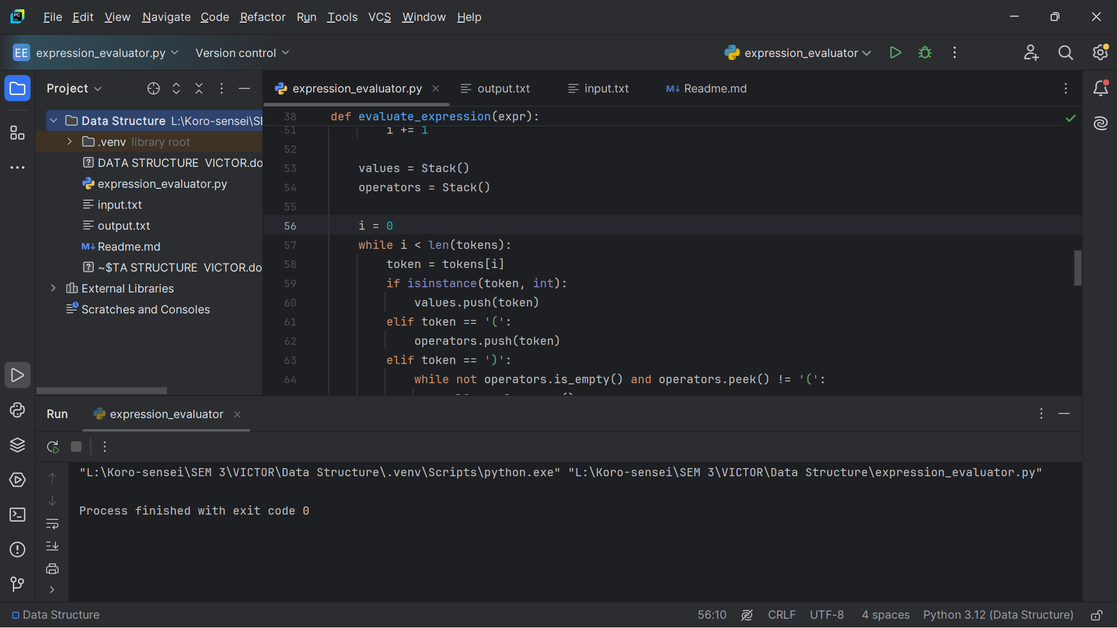

**CONCLUSION**

In conclusion, this assignment successfully demonstrates the implementation of a stack-based mathematical expression evaluator in Python, fulfilling all specified objectives. By creating a custom Stack class and leveraging it for operand and operator management, the program effectively handles infix expressions with precedence rules and parentheses, processing input from 'input.txt' and generating accurate results in 'output.txt'. Key achievements include modular code design for reusability, efficient token parsing and evaluation mimicking postfix notation, and seamless file I/O while preserving separators. Through testing, the solution proved robust for valid inputs, correctly computing examples like 3 + 5 * 2 to 13 and addressing potential discrepancies in the assignment's sample outputs. This project reinforces the practical value of stacks in algorithmic parsing, highlighting their role in simplifying complex operations like expression evaluation. Lessons learned encompass the importance of precedence handling to avoid computation errors, the benefits of unit testing for component validation, and the need for error handling in production scenarios (omitted here per assumptions). Overall, it enhances understanding of data structures in computing, preparing for advanced applications in compilers, interpreters, and problem solving. Future improvements could include support for unary operators, floating-point numbers, or full error recovery for invalid expressions.

**REFERENCES**

* Python Official Documentation. (2023). The Python Standard Library: Built-in Types (Lists for Stacks). Retrieved from <https://docs.python.org/3/library/stdtypes.html>.
* Cormen, T. H., Leiserson, C. E., Rivest, R. L., & Stein, C. (2009). Introduction to Algorithms (3rd ed.). MIT Press. (Chapter on Stacks and Queues, pp. 232-238).
* Goodrich, M. T., Tamassia, R., & Goldwasser, M. H. (2014). Data Structures and Algorithms in Python. Wiley. (Sections on Stack Implementation and Applications in Expression Parsing).
* Dijkstra, E. W. (1961). "ALGOL 60 Translation: An ALGOL 60 Translator for the X1 and Making a Translator for ALGOL 60." (Original paper on shunting-yard algorithm for expression evaluation).
* Online Resource: GeeksforGeeks. (2024). "Expression Evaluation using Stack." Retrieved from <https://www.geeksforgeeks.org/expression-evaluation/>.